First talking about the navigation bars:
Home
Sports
Clubs
Our Team
Hall of Fame( Past Winners)
Newsletter
Gallery
Fcilities(current and upcoming)
Event Schedule (Calendar)
Contact us

Home
https://www.wix.com/website-template/view/html/1896?siteId=c54249f0-9878-4464-9dc0-5cc938a097e4&metaSiteId=2f5a38ee-e1bf-4a2d-a169-8e9670dd4cb0&originUrl=https%3A%2F%2Fwww.wix.com%2Fwebsite%2Ftemplates%2Fhtml%2Flanding-pages
sports theme videos replay in background

Sports

Upcoming Events
http://students.iitgn.ac.in/hackrush/teams.html
Similary we can embed the google calendar to the website

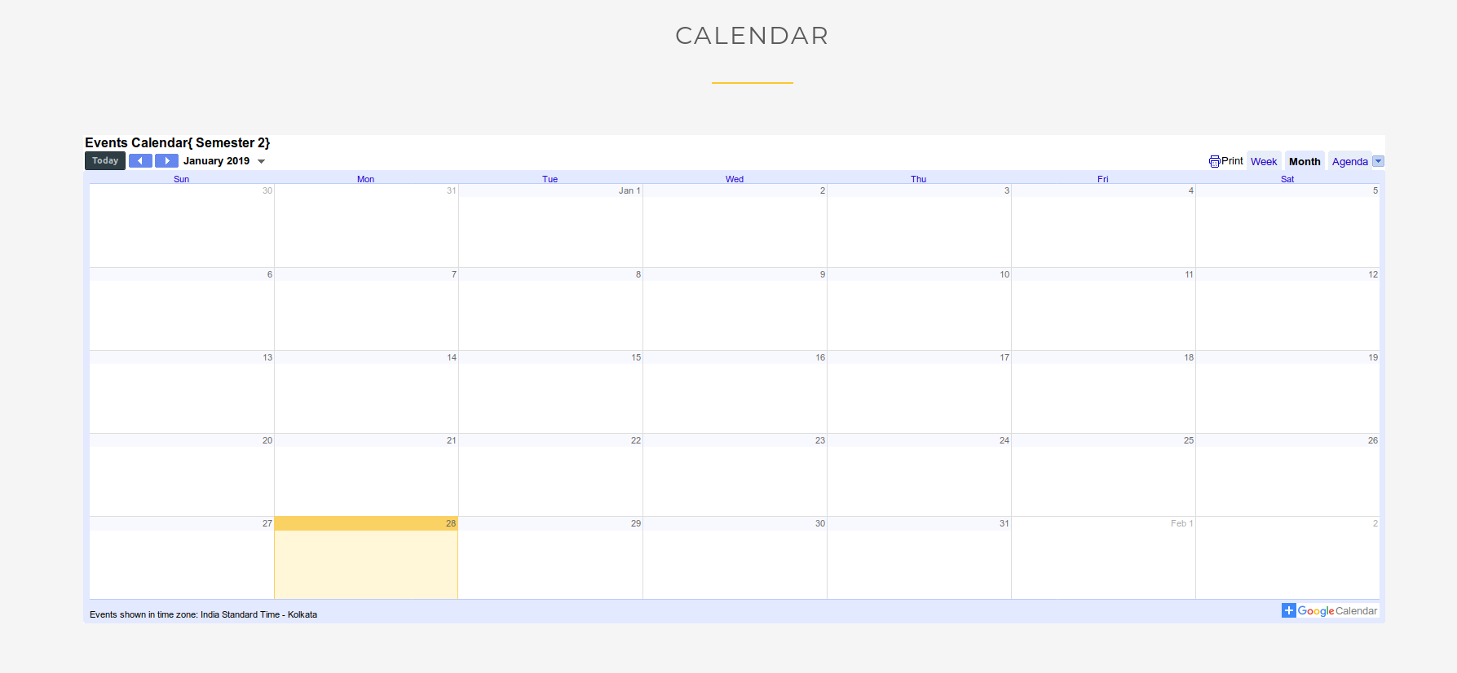
Contact Us
Coaches, Concil and Captains

<!---This is an optional subject-->
Map
For IITGN and sports facilities

Gallery and Newsletter

